Grammar
to be in Past Simple
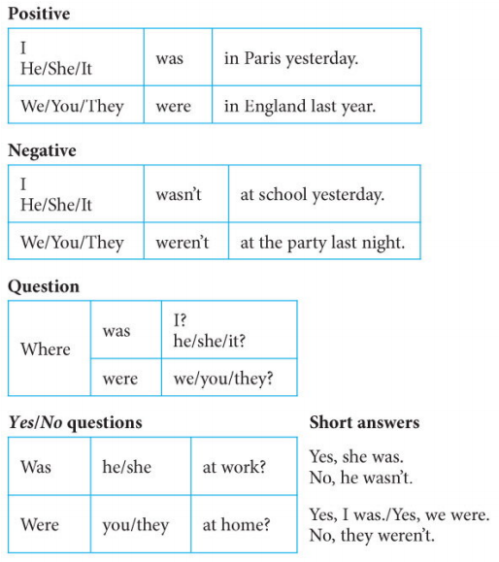
Past Simple (other verbs)
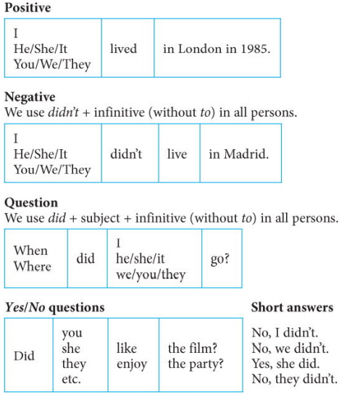

Past Simple (regular verbs)
S V O.
v S V O?

WH | v | S | V | O
 |  | Susy | lived | In NY | +
 |  | Susy | didn’t live | In NY | -
 | Did | Susy | live | In NY | ?
WH | did | Susy | live | In NY | ?

Did + live = lived
Task 1. Fill in the form with negative/question forms of the sentences from the text

WH | v | S | V | O
 |  | Her father | worked | in a coalmine | +
 |  | Her father | didn’t work | at the local radio station | -
 | Did | Her father | work | in a coalmine | ?
Where | did | Her father | work | - | ?

- Her mother cleaned houses.
- Oprah lived with her grandmother.
- She received a scholarship to Tennessee State University.
- She studied drama.
- She started reading the news at the local radio station.
- Oprah moved to Chicago to work on a TV talk show.
- She talked to lots of interesting people.
- People watched the show every week.
- Oprah interviewed Michael Jackson in 1993.
- She earned $260,000,000 last year.
- Oprah opened a special school in Johannesburg.

Task 2. Complete the questions about Oprah.
- Where did her father work? | In a coalmine.
- What….. her mother do? | She cleaned houses.
- Who … Oprah … with? | Her grandmother.
- What … she … ? | Drama.
- When … she … Michael Jackson? | In 1993.
- How much … she … last year? | $260 million.
- When … she … the girls’ school? | In 2007.
- …. Her parents … much money? | No, they didn’t.

Past Simple (to be)
S V O.
V S O?

WH | V | S | V
 |  | Oprah | was | born | in 1954 | +
 |  | Oprah | wasn’t | born | in 1999 | -
 | Was | Oprah | - | born | in 1954 | ?
When | was | Oprah | - | born | - | ?

Task 3. Fill in the form with negative/question forms of the sentences from the text.

- Oprah was born in Kosciusko, Missisipi.
- Her parents were very poor.
- Oprah was clever.
- Her TV talk show was called A.M. Chicago.
- The show was very successful.
- It was renamed The Oprah Winfrey Show in 1985.

Talking about you.
Task 4. Complete the questions with did, was/were

- Where …. your parents born?
- Where … you live when you were a child?
- …. you live in a house or a flat?
- When … you start school?
- Who … your first teacher?
- Who … your best friend?
- When … you learn to read and write?
- When … you get your first mobile phone?

Task 5. Ask a partner these questions. Write down the answers.

Task 6. Write down 5 important dates for you/your family. Learn to read them properly.
E.g. 11.11.1918 – the eleventh of November, nineteen-eighteen – WWI Memorial Day

Task 7. Read the text “The Businessman and the Fisherman” (p50-51).
Write out all the verbs in the Past Simple and give all the 3 forms of the verbs and their translation:

e.g.
Text | Infinitive | Past Simple | Past Participle | translation
was | be | was/were | been | (быть)

